
<<User who generated the Report>>
<<Report Generation Date>>
<<Report Title>>
<<Municipality Logo>>
Logo>>

<<Municipality Name>>

<<Summary>> (1024 words maximum)
A summary of the generated report, describing its purpose.

<<Key indicators>>
Key indicators for the selected period (September–October 2025):
- Total meals served: 16500
- Total waste: 330 kg
- Average waste per meal: 0.020 kg/meal
- Estimated waste cost: 990.00 €

<<Chart>> (Optional)
Example chart generated with this report:
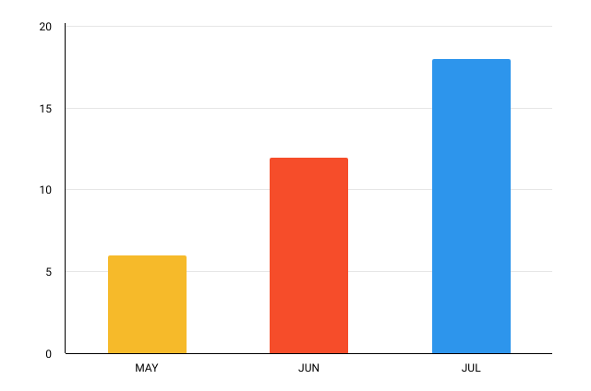

<<Details table>>
The details table contains the exported data. Example:

Period | Canteen | Meals Served | Total Waste (KG) | Waste per Meal (kg) | Estimated cost (€) | Main Cause
09/2025 | Canteen A | 6000 | 120 | 0.020 | 360.00 | Overproduction
09/2025 | Canteen B | 3000 | 70 | 0.023 | 210.00 | Expired Stock
10/2025 | Canteen A | 7500 | 140 | 0.019 | 420.00 | Transport Issues
… | … | … | … | … | … | …
… | … | … | … | … | … | …

